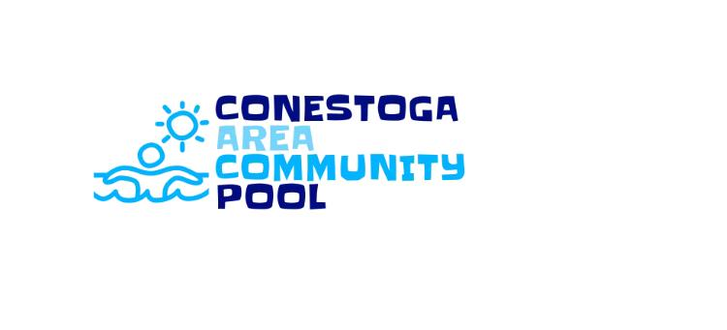
2024 POOL MEMBERSHIP
- Family of 4 or less Annual Pass $275.00 Discounted til May 25, 2024 $325.00 After
- Additional family member $40.00
- Senior (over) 65 Annual Pass $75.00
- Individual Season Pass (16-65) $150.00
- Youth Season Pass (3-15) $125.00

Name ______________________________ Age _______
Address ____________________________ Phone _______________
ADDITIONAL FAMILY MEMBERS
Name ______________________________ Age _______
Name ______________________________ Age _______
Name ______________________________ Age _______
Name ______________________________ Age _______
Name ______________________________ Age _______
X______________________________ Signature of Responsible Party
By signing you release any and all responsibility from Conestoga Area Community Pool, their members, volunteers and employees. You understand the risk involved in the activity of swimming and activities associated with a community pool.
TOTAL DUE $_______________ Checks can be made payable to Conestoga Area Community Pool, 3225 Main Street, Conestoga, PA 17516 Questions? Melanie 717-951-8677

